Android Animations

Step 1

Create **anim** folder inside **res** folder

Step 2

Create new animation resource file

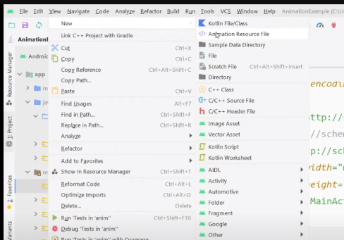

Step 3

**Translate Animation**

Create animation

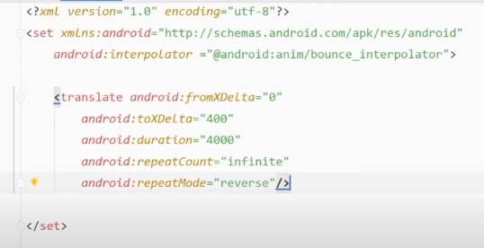

Step 4

Create animation object inside Activity ( java file )

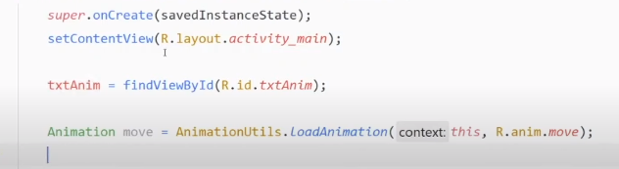

Step 5

Set animation on button click

